Erson Kice

Introduction

Purpose
What is the problem or opportunity being investigated?
The project addresses a significant gap in the travel industry: the lack of privacy-respecting, affordable travel booking platforms. Most major travel websites monetise user data aggressively, leaving travellers with little control over their personal information. This platform offers a privacy-first alternative that also prioritises competitive pricing, giving users both security and value.

Why is this problem valuable to address?
Privacy is increasingly recognised as a fundamental right, yet the travel industry routinely trades user data for profit. At the same time, travel costs continue to rise, making affordable options essential. This project addresses both concerns simultaneously — offering travellers a trustworthy, cost-effective alternative to mainstream platforms.

What is the current state?
Leading travel platforms such as Booking.com and MakeMyTrip aggressively harvest user data, using it to target advertising and personalise pricing — often at the user's expense. A Cybernews investigation confirmed that many popular travel apps collect far more data than necessary, with limited transparency about how it is used or shared.

What is the desired state?
A travel booking website that gives users full control over their personal data, offers transparent privacy policies, and provides competitive pricing — accessible and easy to use for people of all ages and technical backgrounds.

Has this problem been addressed by other projects?
Research into existing platforms found no direct equivalent. While some services offer partial privacy features, none combine comprehensive data protection with competitive pricing and broad accessibility in a single, dedicated travel platform.
Industry / Domain
What is the industry/domain?
Travel technology — specifically online travel booking platforms operating at the intersection of the travel and data privacy industries.

What is the current state of the industry?
The online travel industry is dominated by large platforms that fund their operations primarily through advertising and data monetisation. A Cybernews investigation revealed that many popular travel apps aggressively harvest user data, with minimal transparency. Users are increasingly aware of this practice but lack viable privacy-focused alternatives.

What is the overall industry value chain?
Traditional travel platforms generate revenue through booking commissions, targeted advertising powered by user data, and premium subscription tiers. This platform adopts a similar subscription model — offering a free tier with minimal advertising and a premium tier that removes ads entirely — without relying on the sale or exploitation of user data.

What are the key concepts in the industry?
Customer acquisition, user retention, competitive pricing, trust and brand loyalty. For this platform, trust is the primary differentiator — users return because they know their data is safe and their privacy is respected.

Is the project relevant to other industries?
Yes. The privacy-first model has broader relevance across any industry that handles personal data, including accommodation, transport, and financial services. The platform's accessible design also makes it relevant to digital inclusion initiatives targeting users who find existing travel websites difficult to navigate.
Stakeholders
Who are the stakeholders?
The primary users are internet-enabled travellers of all ages seeking affordable travel options — from young independent travellers to older users booking family holidays. Secondary stakeholders include travel service providers (airlines, hotels, car hire companies) listed on the platform, and privacy advocates who may promote or endorse the service.

Why do they care about this software?
Users care because it offers something the market currently lacks — genuine privacy protection combined with low prices and an intuitive interface that doesn't require technical expertise. Service providers benefit from access to a growing audience of privacy-conscious consumers.
What are the stakeholders' expectations?
Users expect a straightforward booking experience with competitive pricing, confidence that their personal data will not be shared or sold without explicit consent, and a platform accessible to users of all ages and technical abilities. The core promise is simple: great prices, easy to use, and your data stays yours.

Product Description

Architecture Diagram
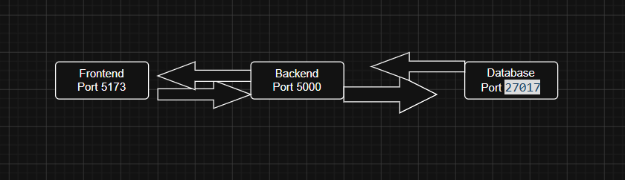

User Stories
Table Below

# User Story Title | User Story Description Priority | Additional Notes

1 Privacy I would like to b book my
holidays in a private
environment High

2 Feedback I would like to leave feedback
on my holiday High

3 Watching a video of others I would like to each a video of
other people’s holiday if they
post them Low

4 Creating an Account I would like to create an account
to book a holiday High

5 Adding an adventure I would like to add an adventure
for my holiday High

6 A list of holidays I would like to see a list of
adventures High

7 Editing my adventure I would like to be able to edit
my booked adventures High

8 Delete an adventure I would like to delete an
adventure High

Wireframe Design

Figma Bellow

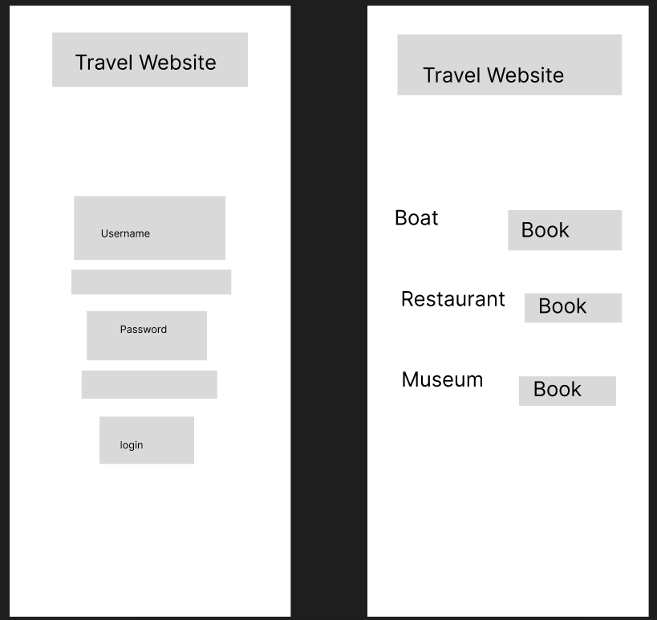

Open Questions/Out of Scope

● What features are considered out of scope?
Images/videos of the adventure, other people's feedbacks and low prices.

Non-functional Requirements

● What are the key security requirements? (e.g. login, storage of personal details, inactivity timeout, data encryption)

● How many transactions should be enabled at peak time?
1000 per sec

● How easy to use does the software need to be?
It's easy for all ages

● How quickly should the application respond to user requests?
As fast as possible

● How reliable must the application be? (e.g. mean time between failures)
100% active 24/7, max 1 hour between failure

Project Planning

I use GitHub to see issues and updates because my project is into my GitHub repository.

Monday 12 I made researches about what to do as my project.

Tuesday 13 I started my documentation.

Wednesday 14 I made my backend with javascript with MVC.

Thursday 15 I tested my backend and fixed some errors.

Friday 16 I made my frontend.

Saturday 17 I tested my frontend and fixed some errors.

Sunday 18 I made my database on MongoDB.

Monday 19 I tested my database and fixed some errors.
.
Tuesday 20 Creating my presentation.

Wednesday 21 I’m testing my website and trying to test my presentation.

Testing Strategy jest and thunderclient

● What were steps undertaken to achieve product quality?
I made lots of researches about other travel websites, made lots of tests, codes are easy to understand because I added comments

● How was each feature of the application tested?
With all the principal softwares and by hand

● How did you handle edge cases?
I tested every code before adding new ones to be sure it worked well

Implementation

● What were the considerations for deploying the software?
Using AWS EC2 with docker-out of scope
Deployed locally

End-to-end solution

● How well did the software meet its objectives?
very well, the website is functional that help people enjoy their trips

References

● Where is the code used in the project? (link to GitHub)
GitHub: https://github.com/ErsonAus/Capstone

● What are the resources used in the project? (libraries, APIs, databases, tools, etc)
Libraries, API, Database, Tools, Controllers, Models, Routes, MongoDB, React and JavaScript.

